Capstone Project

Document Skeleton

Process overview
The following diagram shows the overall end-to-end process for defining, designing and delivering the Capstone project.

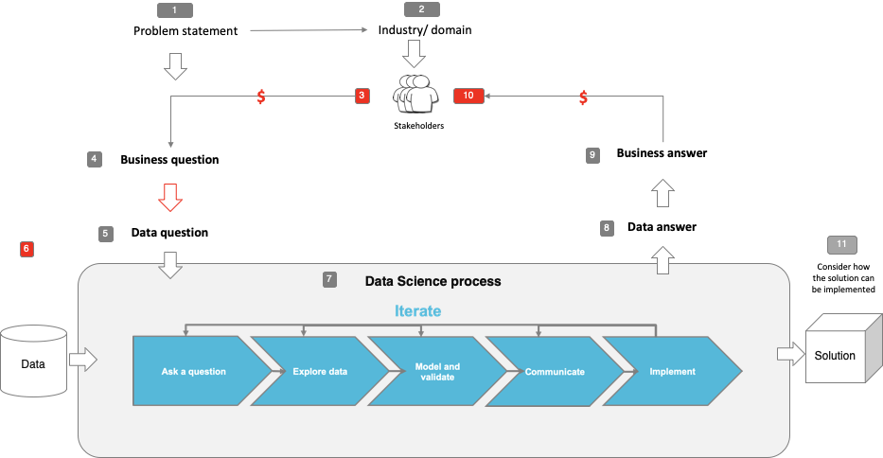

Note: The following are the candidate sections of the document. They are presented here for guidance. Questions in each section could be used as possible aspects to cover. Some questions may not be applied to each project. On the other hand, additional information may be needed.

Problem statement
- What is the problem or the opportunity that the project is investigating?
This project aims to predict bitcoin price and to the extent to whether social media influence bitcoin price.

- Why is this problem valuable to address?
The market capitalisation for cryptocurrency has increase significantly from US$127.5 billion in January 2018 to US$1.75 trillion in May 2021, which has increased 13 times over the period (CoinMarketCap, 2021). However, the cryptocurrency is highly speculative investment (SEC, 2021). As the cryptocurrency market is a great setting to investigate the market sentiment as there is no fundamental value to the currency, no government or central bank backing, and no price sensitive information such as company’s earnings announcements would influence the bitcoin valuation (Mai, et al., 2018). Given the setting, a key driver which will affect the value of the cryptocurrency is social media (Mai, et al., 2018). Therefore, the analysis of the information on social media will provide good indication of the market sentiment which will help investors to enhance their risk management.

- What is the current state (e.g. unsatisfied customers, lost revenue)?
Although bitcoin price has increased significantly over the years (refer to figure 1 below), the market sentiments on investing bitcoin is mixed based on anecdotal evidence. Refer to some of screenshots of the news headlines shown below.

Figure 1
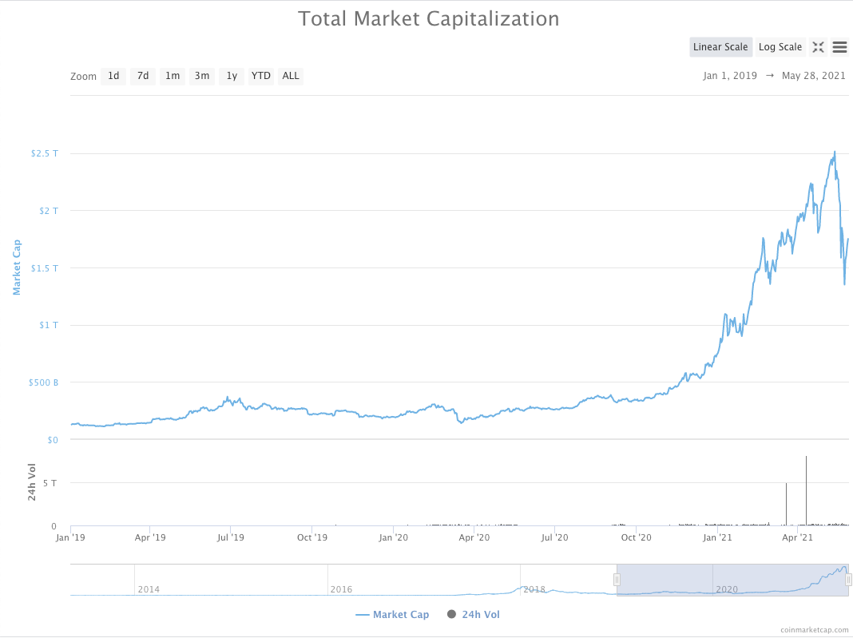

News headlines






- What is the desired state?

Effective risk management when trading bitcoin.

- Has this problem been addressed by other research projects? What were the outcomes?

Yes. Some recent studies have addressed this problem. The list of research projects are listed below.

Kristoufek, L., 2013. BitCoin meets Google Trends and Wikipedia: Quantifying the relationship between phenomena of the Internet era. Scientific reports, 3(1), pp.1-7.

Perry-Carrera, B., 2018. Effect of Sentiment on Bitcoin Price Formation (Doctoral dissertation, Duke University Durham).

Abraham, J., Higdon, D., Nelson, J. and Ibarra, J., 2018. Cryptocurrency price prediction using tweet volumes and sentiment analysis. SMU Data Science Review, 1(3), p.1.

QFX Resarch, 2019. Can we predict Bitcoin price using Google Trends?, <https://medium.com/qfx-research/can-we-predict-bitcoin-price-using-google-trends-e29ae7d3e58a>

https://github.com/Aaron-Paul/Bitcoin-Price-Twitter-Sentiment-Analysis

Industry/ domain
- What is the industry/ domain?
Finance and investment.

- What is the current state of this industry? (e.g. challenges from startups)
A high volatile market

- What is the overall industry value-chain?
Investor -> broker -> investor

- What are the key concepts in the industry?
Based on efficient market hypothesis (EMH), the value of the price should reflect all information.

- Is the project relevant to other industries?
Yes. This project can be extended to equity stock market.

Stakeholders
- Who are the stakeholders? (be as specific as possible)
Portfolio manager, investment manager, investment analyst, and retail investors.

- Why do they care about this problem?
To effectively manage risk and volatility.

- What are the stakeholders’ expectations?
To minimise their risk and loss and maximise their return.

Business question
- What is the main business question that needs to be answered?
Can we predict bitcoin price and enhance risk management using social media?

- What is the business value of answering this question? (quantify value and make necessary assumptions)
This would be hard to quantify due to market fluctuation.

- What is the required accuracy? What are the implications of false positives or false negatives?
This question does not apply to this study as this is not a classification problem.

Data question
- What is the data question that needs to be answered?
Which of the information from different social media is better at predicting the bitcoin price?

- What is the data required to answer the question?
Bitcoin price, twitter data, google trends data, and Wikipedia page view data.

Data
- Where was the data sourced?
Twitter API (tweepy); google trends (pytrends); Wikipedia page views (pageviewapi); bitcoin price (CoinBase API)

- What is the volume and attributes of the data?
510 observations with 5 features and for the period between January 2020 to May 2021

- How reliable is the data?
Very reliable.

- What is the quality of the raw data?
Very good.

- How was this data generated?
Generated through online queries.

- Is this data available on an ongoing basis?
Yes, it is a public data.

Data science process

Data analysis
- What data pipeline was to wrangle the raw data?
Merged all 4 database based on daily basis.

- What are the highlights of the Exploratory Data Analysis (EDA)?
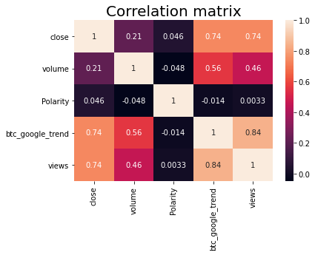
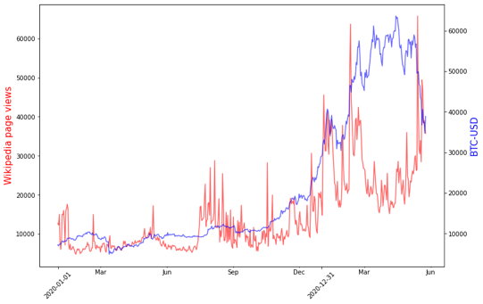
- Is the pipeline reusable? (for example, to process future data?)
Yes.
- What are the intermediary data structures used (if any)?

Modelling
- What are the main features used?
The main features are Bitcoin price, volume, polarity, google trend, Wikipedia page views.

- Did you find any interesting interactions between features?
Google trends had the lowest loss function and most closely predicted the bitcoin price.

- Is there a subset of features that would get a significant portion of your final performance? Which features?
Google trends

- How did you select features?
Based on domain knowledge, these three social media are main source to for understanding the market sentiment. For the future study, there are other social media which can be included in the study.

- What feature engineering techniques are used?
The data was generally clean. Scaled the data.

- What are the models used?
Performed Long short-term memory (LSTM) and various other models for additional tests, including Random Forest, Linear Regression, Lasso Regression, DecisionTreeRegressor, KNeighborsRegressor.

- How long does it take to train your model?
A few minutes.

- What are the tools used? (cloud platform, for example)
Jupyter notebook

- What are the model performance metrics?
MSE

- Which model was selected?
LSTM, linear regression and lasso regression

Outcomes
- What are the main findings and conclusions of the data science process?
Google Trends and Wikipedia page views show a high positive correlation with bitcoin price.

Based on LSTM model using 3 days as the timesteps, LSTM with Google Trends and Wikipedia have the lowest loss function.

The prediction line including all social media is closest to the validation data.

Other models such as linear regression and lasso regression have high accuracy scores.

Implementation
- What are the considerations for implementing the model in production?
Social media information can help us to explain the variation in bitcoin price and predict the bitcoin price.

Data answer
- Was the data question answered satisfactorily?
Yes. Using these features, we have plotted the prediction of bitcoin price.

- What is the confidence level in the data answer?
Loss function for LSTM is 0.004 and accuracy scores for Random forest, Linear regression and Lasso regression are above 98%. Lasso regression had the highest accuracy score of 99.192%.

Business answer
- Was the business question answered satisfactorily?
Yes, the social media information influence and help to predict bitcoin price.

- What is the confidence level in the business answer?
The models and the prediction line shows a close relationship with prediction and actual dataset.

Response to stakeholders
- What are the overall messages and recommendations to the stakeholders?
By analysing social media information and incorporating these information, the stakeholders can manage their risk more effectively.

End-to-end solution
- What is the overall end-to-end solution to use the model developed in the project?
Social media information can be incorporated when managing investment portfolio.

References
- Where are the data and code used in the project? (show a simplified list of main items: notebooks, datasets, exported models)
Available at: IOD shared folder

- What are the resources used in the project? (libraries, algorithms, etc)
Available at: IOD shared folder

